**Refugee Resettlement Benefit Map**

**Introduction**

This document outlines the methodology used by World Relief Durham to creating a benefit map for refugee living locations. The method is applied specifically to World Relief Durham within the confines of Durham, NC. However, the methodology is general and can be applied to any resettlement location.

The reason for creating a benefit map is to:

1. Guide World Relief in choosing locations to settle refugees if multiple options are present
2. Guide landlords wishing to partner with World Relief to select strategic investment properties

Definitions:

* *Desirability*: how valuable a particular location is as a location for a refugee family to live
* *Benefit map*: a map of a city or region that has overlays of colored regions, each color indicating a range of desirability

**Desirability**

What makes a particular location desirable for a refugee family?

The benefit map takes into consideration the following criteria:

1. Close to efficient bus lines
2. Close to lower cost food shopping
3. Close to key resource locations
4. Close to potential employment locations
5. Safe neighborhood

The list of lower cost food shopping includes the following:

* Food Lion
* Kroger
* Walmart
* Walmart Supercenter
* Walmart Neighborhood Market
* Supertarget
* ALDI
* Lidl
* Publix
* Lowes Foods
* Compare Foods
* Save-A-Lot
* Food World

The following are excluded from the list due to to their price:

* Whole Foods
* Harris Teeter
* Trader Joe’s
* Sam’s Club

A key resource location is any location in Durham that is unique, universal and necessary for refugee families being resettled by World Relief Durham within the context of Durham County. This includes the primary resettlement agency, resettlement employment agencies, county social services, main bus terminal and main hospitals.

The key resource locations for World Relief Durham is as follows:

* World Relief Durham (801 Gilbert St #209, Durham, NC 27701)
* Durham Social Services (414 E Main St, Durham, NC 27701)
* Church World Service (112 S Duke St # 4B, Durham, NC 27701)
* Durham Station (515 W Pettigrew St, Durham, NC 27701)
* Duke Hospital (2301 Erwin Rd, Durham, NC 27710)
* Duke Regional Hospital (3643 N Roxboro St, Durham, NC 27704)

The following resource locations do not qualify for the above list:

* Lincoln Community Health Center does not qualify as unique because there are many community health clinics in Durham County that provide the same services.
* Social Security Administration does not qualify because it is not universal and necessary for every client beyond the first week of arrival.
* Durham Literacy Center does not qualify as universal or in some cases, necessary, because there are many literacy and ESL programs whose utility depend on the specific needs of each refugee.
* The Department of Motor Vehicles does not qualify because there are multiple locations in based on needs that are not universal or in some cases, necessary, to all refugees.

There are some things that are intentionally not listed criteria in order that the map may be used for both reasons listed in the description:

* Property cost
* Rental cost
* Residence size

Determine the *relative* importance of each of the Criteria using a value between 0.0 (no value) and 1.0 (very high value). Let’s call this the ***weight***. (for example is closeness to low cost food more or less important than closeness to a bus line?):

1. 0.32 = Close to efficient bus lines
2. 0.25 = Close to lower cost food shopping (eg. Food Lion)
3. 0.16 = Close to potential employment locations
4. 0.15 = Safe neighborhood
5. 0.12 = Close to key resource locations (eg. World Relief Durham)

For a given location on a map there will be some amount of matching for each criteria, (eg. *how* close is this spot to a bus line). Let’s call this: the ***value*** of the location for a specific criteria. These values should be between 0.0 and 1.0. A suggestion is to use only a few levels for each criteria, (eg. 0.0, 0.25, 0.5, 0.75, 1.0 or 0.0, 0.5, 1.0).

**Value Determination**

**Criteria a) Close to efficient bus lines**

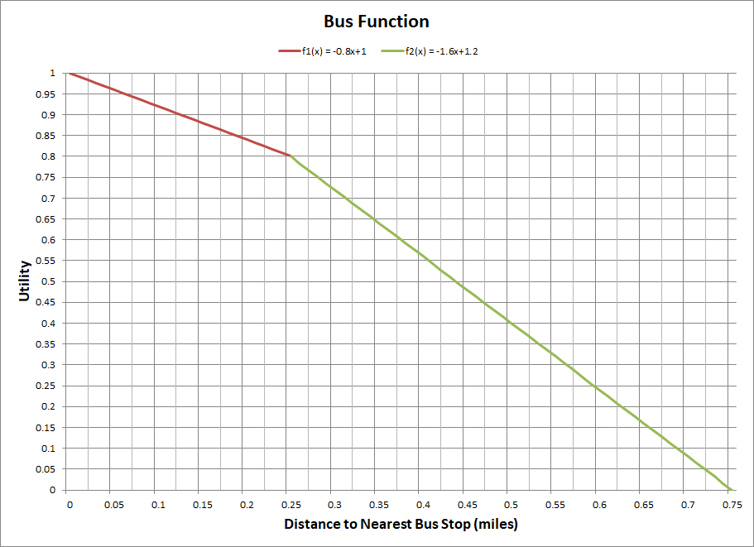

The Bus Function only gives positive values for locations that are within 0.75 miles (15 minutes) of a bus stop. World Relief is not interested in resettling refugees in any distances further than this maximum. The utility decreases at a faster rate after 0.25 miles (5 minutes by foot) because from this point on it requires increased effort to walk each additional distance. The utility of a 0.25 (5 mile) walk is around 0.8 while the utility of a 0.5 (10 mile) walk is approximately 0.4.

**Criteria b) Close to lower cost food shopping**

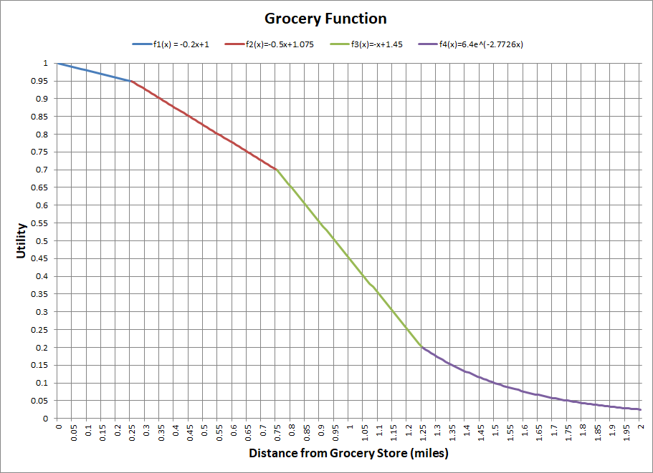

The Grocery Function also takes into the account the increased effort required to walk additional distance after 0.25 miles. The utility decreases fastest between 0.75 and 1.25 miles because this is the region in which a client would decide to take a bus. Therefore, both the increased distance and increased monetary price makes an 1.25 mile walk to the bus stop much worse than 0.75 miles. The last portion of the graph, which is exponential and never reaches zero, decreases at a decreasing rate because riding the bus for 20 minutes is not much worse than riding the bus for 10 minutes.

**Criteria c) Close to key resource locations**

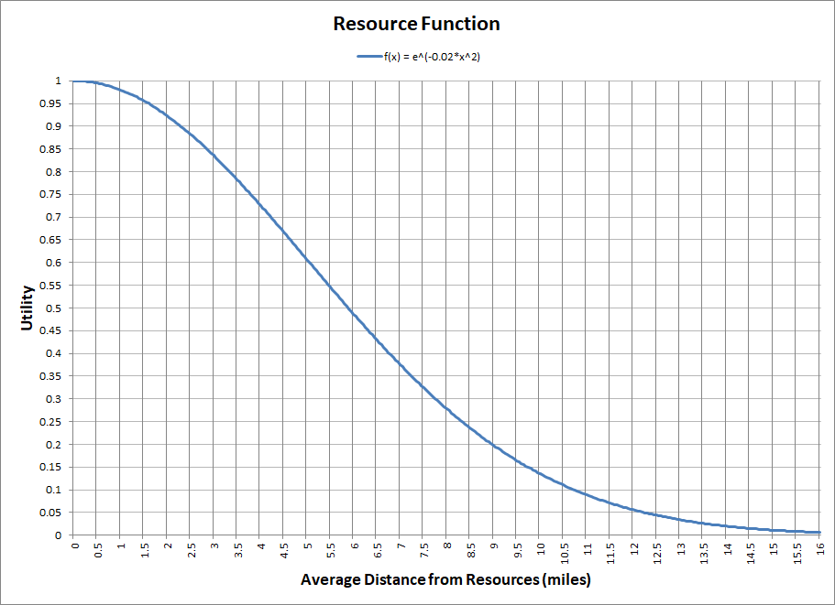

The resource function is a Gaussian integral based on the specific size of Durham. The integral remains positive until infinity but the 16 mile cutoff represents the furthest average distance that a given location will be to key resource locations in Durham. The utility is fairly constant for the first mile due to their walking convenience and increases as the average becomes less walkable and busable (requires more than one bus route, which is also more expensive). The slope begins to decrease around 6.5 miles (distance from Downtown Durham to Seven Oaks Townhomes) since with this large average distance the utility is already low and any additional distance would not be too much worse.

**Criteria d) Close to potential employment locations**

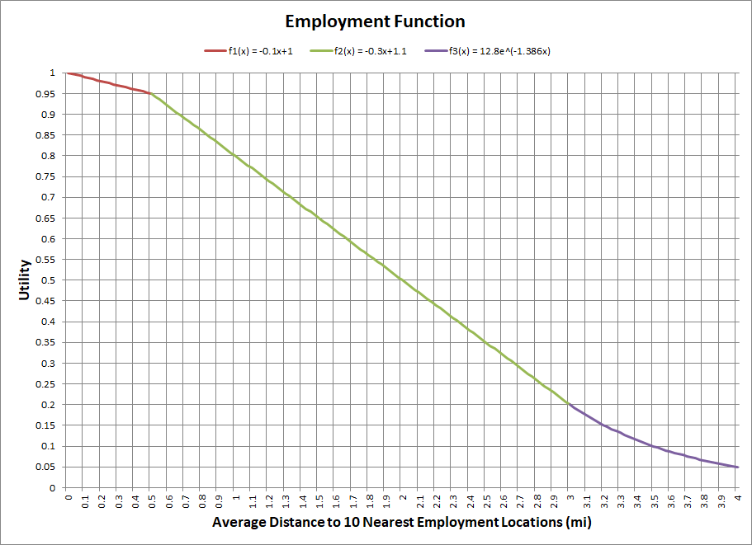

The Employment Function averages the 20 nearest possible employment locations coming from a search of all hotels, restaurants, bakeries, cafes and supermarkets. These are the top employment locations for World Relief in Durham. The utility remains fairly high for an average below 0.5 miles because in this region employment is probably available in a nearby shopping center or commercial area, which makes work convenient. World Relief Durham, located near Downtown Durham, falls on the back end of this spectrum and will score around a 0.9-0.95 for utility. The utility then decreases at a steadily decreasing rate as the distance to job locations by bus increases. The average suburban house will probably have a score of between 0.4-0.6 (1.5-2.5 miles, on average, from a shopping center or commercial area). The utility after 3 miles has consistently low utility (while never going to zero) because the utility is already bad and the distance by bus is already difficult to manage.

This methodology, when applied consistently, gives a general sense of employment opportunities for any given location. The function above works for averages of no less than 20 locations in order to account for outliers, as well as the overall employment process. We have reason to believe that in a group of 20 locations, an average of 10 locations might be hiring and therefore an average of 2-4 locations will lead to employment opportunities.

**Criteria e) Safe neighborhood**

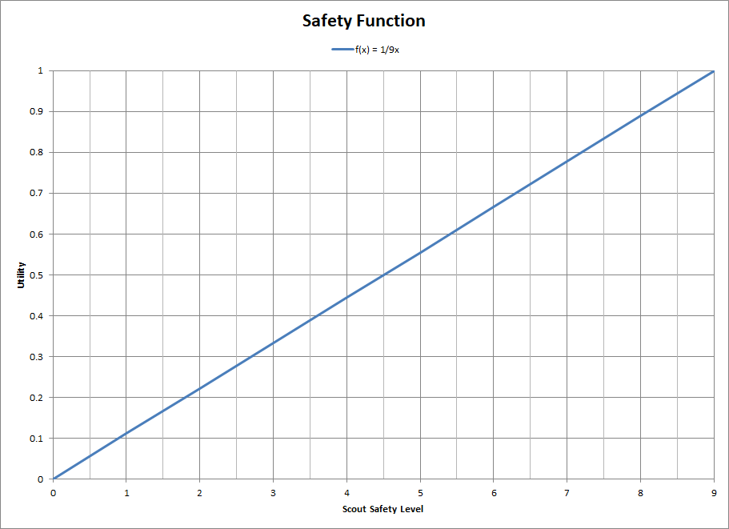

Safety is determined using data from [Neighborhood Scout](https://www.neighborhoodscout.com/nc/durham/crime), which is a reputable source. There are 10 color codes which correspond to values 9 (most safe), 8, 7, 6, 5, 4, 3, 2, 1, 0 (least safe):

**Benefit Map**

Creating the benefit map will require some repetition and revision. Some steps that may be used in order to create a benefit map:

1. do all the initial work as an expert individual and then have it reviewed and then revise as necessary
2. start with a blank map of the desired area, perhaps a large paper printout although this can be done using a sharable google map which might be less effort and would make it easy to update
3. highlight each of the criteria with different colors (eg. bus lines, low cost food)
4. highlight each block of housing with a new color
5. for each block of housing estimate the ***value*** for each criteria and label the map
6. get this reviewed to solidify the ***values***
7. for each block of housing calculate the ***desirability*** = ***weighted*** sum of the ***values*** and label the map
8. get this reviewed and determine ranges of ***desirability*** to use for the final map (maybe 2 or 3 ranges)
9. Digitize this paper map (using sharable google maps) or update the existing google map by creating desirability range layers. Place a pin for each housing block in the layer matching its desirability range

As criteria shifts over time the map needs to be updated. This update would have to be done in all the layers affected, ***values*** and ***desirability***. There is a way to write a program to do this, so if someone wanted to, this could become a software tool that could then be leveraged across all World Relief locations.

**Mathematical Formulation**

This section is not required for a general understanding but formalizes the goal for those who can benefit from reading this for extra understanding. Desirability is a function over the two dimensional space of a map d(x, y). Each criteria is also a function over the two dimensional space of a map a(x,y), b(x,y), etc. It is impossible to know what this function is exactly (would involve God-powers) so we approximate it like this: d(x,y) = w0 * a(x,y) + w1 * b(x,y) + … as a weighted sum of the criteria functions at the same location.

**FAQ**

Q: How many colored regions should there be?

A: no color means “not desirable” or “ignore”. 2 colors are probably sufficient given the coarseness of the approximation of the desirability value